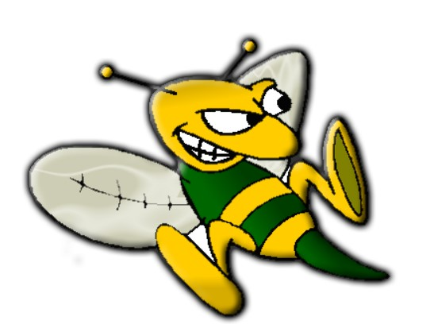Activities for Students @ Helen Fort 2023-24

| **Clubs** | **Advisor/Coach** |
| --- | --- |
| Anchored for Life | Nicole Roccato, Pat Hines, Julie Johnson |
| Anime Club | *TBD* |
| Art Club | *TBD* |
| Cheerleading | Stephanie Harmon |
| Chess & Games Club | Eric Dennis, Kate Heck |
| Choral Club | Afton Pressley |
| Cultures Club Studies | Scott Golluscio |
| Cooking Club | Dawn Piterski |
| Gender & Sexuality Alliance | Amanda Schott |
| Instrumental Music Club | Frank Zintl |
| Mentorship through Music | Scott Golluscio |
| Robotics Club | Shannon Robertson |
| **Interscholastic Sports** |  |
| Boys Basketball | Mark Schaefer |
| Girls Basketball | Nicole Roccato, Desiree Macey |
| Boys Baseball | Mike Lamola, Daniel Koon |
| Cross Country | Stephanie Harmon, Eric Dennis |
| Field Hockey | Desiree Macey, Shannon Robertson |
| Boys Soccer | *TBD*, Chris Mazzarelli |
| Girls Soccer | Scott Golluscio, DeAnna Richardson |
| Girls Softball | Scott Golluscio, Shannon Robertson |
| Track | Mike Martusus |
| Wrestling | Mike Lamola, Dan Koon |
| **Intramural Sports** |  |
| Flag Football (Co-ed) | Mike Martusus |
| Basketball HFMS (Co-ed) | Nicole Roccato |
| Soccer (Co-ed) | *TBD* |
| Volleyball (Co-ed) | Scott Golluscio |
| Performance Team | *TBD* |
| **Event** |  |
| Music/Theater Arts | Shannon Robertson, Afton Pressley |
| National Jr Honor Society | Kate Heck, Shannon Robertson |
| Rogate/Model Congress | Danielle Grgas, Mike Martusus |
| Student Council HFMS | Michael Wanat, Pat Hines |
| Woodshop Club HFMS | Wayne Mocci |
| Yearbook HFMS | Marcy Scollay, Tricia Kouch |